SQLUpdateStep

Objective:

It is used to execute the update SQL in selected DB. An Update Query is an action query(SQL statement) that changes a set of records according to criteria (search conditions) you specify. It's a very powerful feature and a fundamental part of relational databases since you can modify a huge number of records at one time.

## UI

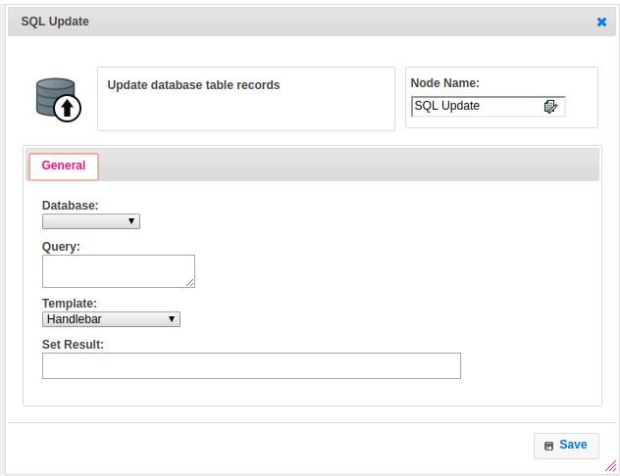

## Attributes:

|  |  |
| --- | --- |
| **Attributes** | **Description** |
| Query | A query is a request for data or information from a database table or combination of tables. An Update Query is an action query(SQL statement) that changes a set of records according to criteria (search conditions) you specify. It's a very powerful feature and a fundamental part of relational databases since you can modify a huge number of records at one time. |
| Template | To select type as free marker template or handlebar |
| Database | The name of the plugin which we configured earlier with server, username, password and schema |
| Set Result | Used to store the response of the step |

## Executor Description:

* In executor class first will get connection to database based on the plugin handler credentials to respective schema.
* By using the SQLDBUtil class we will update the data based on the query or value which given by user and put result into output variable then returns success.

## Dependent plugins:

|  |  |
| --- | --- |
| **Attributes** | **Description** |
| server | The host name "localhost" might resolve to "127.0.0.1" or "::1" on your host, so note this when checking permissions. For example, if a web application's user only has access to "127.0.0.1" on a host, and a defined connection uses "localhost" that resolves to "::1", this connection may lack the proper permissions to the aforementioned web application. User can provide another server url when they want to connect with their host. |
| username | Username to use for the connection. For localhost default is root. |
| password | Optional password for the account used. If you enter no password here, you will be prompted to enter the password when MySQL Workbench attempts to establish the connection. MySQL Workbench can store the password in a vault. |
| schema | When the connection to the server is established, this is the schema that will be used by default. It becomes the default schema for use in other parts of MySQL Workbench |

## Resource:

For more information please refer the below link

<https://dev.mysql.com/doc/>